EuroBank

exhibit 13

Reports

Table of Contents
1. INTRODUCTION 1
2. REPORTS 1

- INTRODUCTION
This Exhibit sets forth the reports that the PST Supplier will provide, as of the Commencement Date unless otherwise specified, for all Services described in the MSA.

EuroBank and PST agree on the principle that the current reporting solution and content is not efficient. PST will, as part of the Transformation Phase, implement a new reporting solution based on a reduced number of reports. EuroBank and PST will cooperate in good faith to achieve a reduction to a target number of around 50 reports, subject to EuroBank business requirements. EuroBank will actively support the consolidation of the reporting. All reporting issues will be reviewed and agreed as part of the Service Delivery Board activities,

- REPORTS
The PST Supplier’s approach, including functional and technical solutions, to the delivery of the reports currently being provided by the In Scope organization, including those reports specified in Attachment 13-A (Description of Reports) and its approach to providing any other reports as specified in this MSA, or required during the course of providing the Services, is given below:

PST uses the following approach to provide any reports as specified in the MSA, or required during the course of providing the Services:

From Commencement Date during Transformation:

• Deliver reports currently provided (at Commencement Date) by the In Scope organization as defined in Attachment 13A (Description of Reports) by re-using current EuroBank tooling;

• During Transformation the PST Suppliers will deploy the tools planned for this engagement;

• An interim invoice process has been agreed during Preparation Phase and will be effective as of Commencement Date.

From Commencement Date after completion of Transformation:

• Deliver reports using the tools deployed during the Transformation Phase;

• Any additional reporting requests from EuroBank will be managed through the formal Change Control Procedure;

• During the course of providing the Services, PST will improve reporting and performance management by following the best practice guidelines/ approach below:

• Set the baseline early; at best before Service delivery has started to avoid discussion whether Service has improved or not

• Start reporting early based on the baseline set

• Keep performance measures flexible and performance measurement system in sync with EuroBank’s requirements

• Tie outcomes to incentives and penalties to make them bite – quality is just as important as cost to be able to reward good service and penalize bad service.

• Don’t measure just the PST Supplier’s performance – end-to-end processes cover both the service provider and the end user

• Drill measures down through to the individual – the more that career models are linked to performance measurement, the more individuals will be motivated to excel

• Don’t go overboard – don’t over-engineer. Give consideration to where EuroBank is in the outsourcing lifecycle and what is really important

• Automate as much as possible – the more that manual intervention can be eliminated, the less effort-intensive and the more accurate the measures will be.

2IM will provide reports based on electronic data received from PST Suppliers.

In accordance with this, 2IM will implement an online web-based client service and performance management reporting system, which provides all Critical Service Level relevant performance data, with the following benefits:

• Automated Service Level reporting with charts and graphs

• The provision of digital dashboard views of Service performance

• Comparisons of historical and current performance against targets

• Content management allowing Service Delivery Managers to fully communicate and explain performance trends

• Standard balanced scorecard templates and supporting reports for aggregated monthly reporting

• Standard metrics and metrics architecture being made available

• Providing the ability to add additional metrics and custom reports

Example pages of the online reporting tool can be found below but can be customized to EuroBank’s needs:

Service status dashboard:

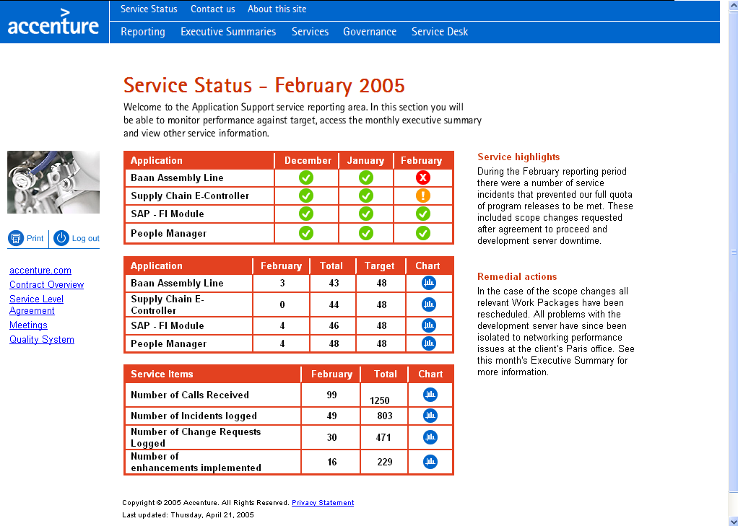

Executive summary with metrics and headlines:

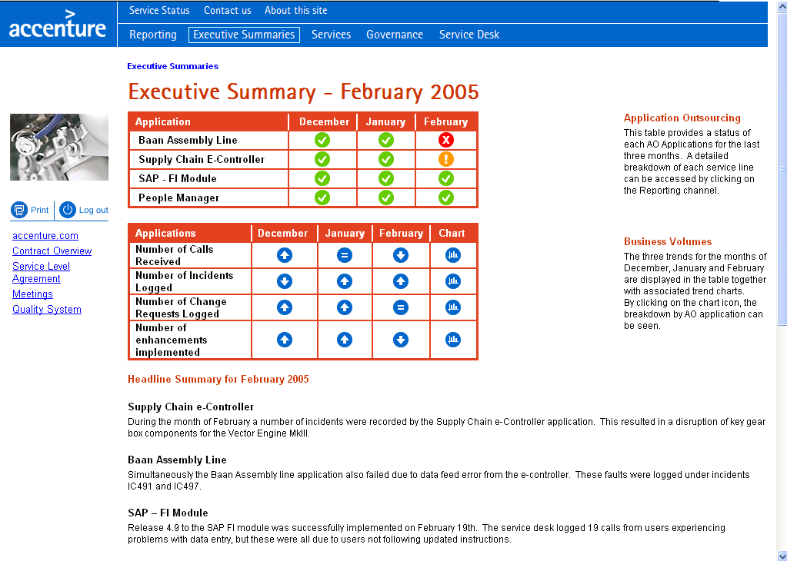

This system will also serve as the centralized service portal for documentation on templates, processes, tools etc. For example, this repository will contain documentation on the agreed SLAs and metrics, a sample of which is printed below:

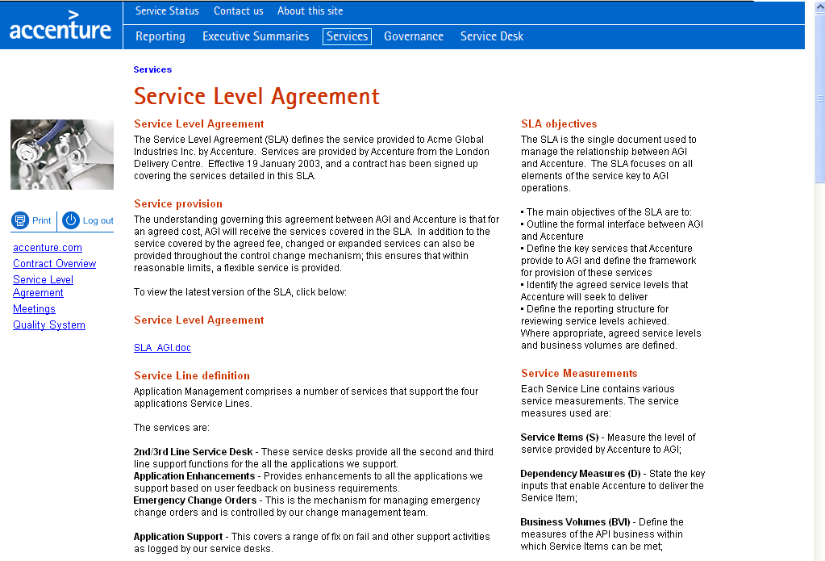

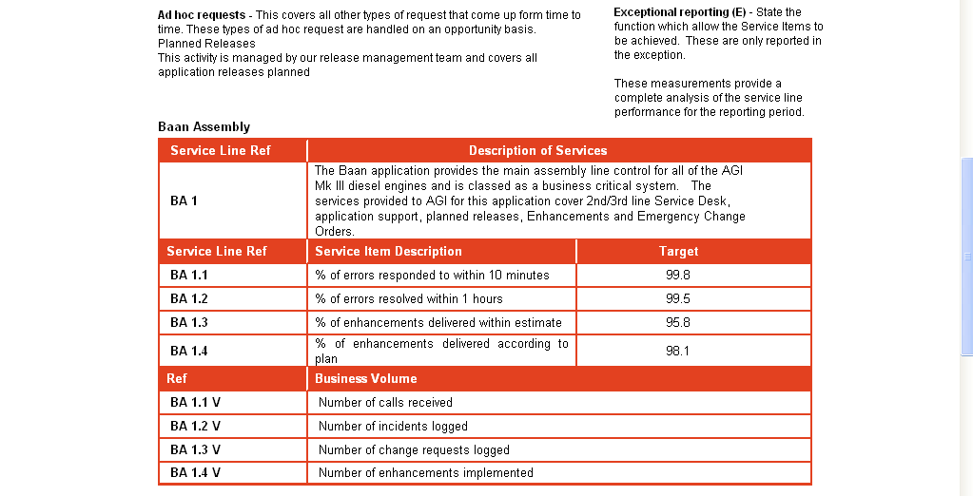

The PST Supplier’s approach to providing a list of any additional reports that it needs to provide during the course of providing the Services, in order to demonstrate and manage effective and efficient delivery of the Services, is given below:

2IM believes that the reports already listed by EuroBank in Attachment 13A (Description of Reports) are more than sufficient to demonstrate and manage effective and efficient delivery of Services.
Any additional reports that may be required during the course of the contract are discussed and agreed with EuroBank as part of the Change Control Procedure.

The PST Supplier’s responsibilities include:

a) Providing all reports currently being provided by the In Scope organization, including those reports listed in Attachment 13-A (Description of Reports).

PST will provide reports currently provided by the In Scope organization as defined in Attachment 13A (Description of Reports) from Commencement Date onward until end of Transformation.

b) Delivering all report data according to the format, content, and frequency provided by the In Scope organization, including the specifications identified in Attachment 13-A (Description of Reports).

PST will deliver all report data according to the format, content, and frequency provided by the In Scope organization, including the specifications identified in Attachment 13-A (Description of Reports) after Transformation

c) Modifying the format, content, and frequency of any report as requested by EuroBank during the Term, subject to Change Management procedures.

PST will modify the format, content, and frequency of any report as requested by EuroBank during the Term, subject to Change Control Procedures.

d) Delivering all reports requested within this MSA.

PST will provide reports currently provided by the In Scope organization as defined in Attachment 13-A (Description of Reports) from Commencement Date onward.

